Gambia, The

## Respect for rule of law (ROL) data

The data set shows the data on the respect of the rule of law for the country.

## # A tibble: 19 x 5  
## country iso3c date ruleOfLaw ruleOfLawCategory4   
## <chr> <chr> <dbl> <dbl> <chr>   
## 1 Gambia, The GMB 1996 0.0170 ROL moderately respected   
## 2 Gambia, The GMB 1998 -0.0554 ROL moderately disrespected  
## 3 Gambia, The GMB 2000 -0.204 ROL moderately disrespected  
## 4 Gambia, The GMB 2002 -0.345 ROL moderately disrespected  
## 5 Gambia, The GMB 2003 0.103 ROL moderately respected   
## 6 Gambia, The GMB 2004 -0.401 ROL moderately disrespected  
## 7 Gambia, The GMB 2005 -0.379 ROL moderately disrespected  
## 8 Gambia, The GMB 2006 -0.360 ROL moderately disrespected  
## 9 Gambia, The GMB 2007 -0.312 ROL moderately disrespected  
## 10 Gambia, The GMB 2008 -0.413 ROL moderately disrespected  
## 11 Gambia, The GMB 2009 -0.506 ROL moderately disrespected  
## 12 Gambia, The GMB 2010 -0.555 ROL moderately disrespected  
## 13 Gambia, The GMB 2011 -0.543 ROL moderately disrespected  
## 14 Gambia, The GMB 2012 -0.577 ROL moderately disrespected  
## 15 Gambia, The GMB 2013 -0.643 ROL moderately disrespected  
## 16 Gambia, The GMB 2014 -0.689 ROL moderately disrespected  
## 17 Gambia, The GMB 2015 -0.721 ROL moderately disrespected  
## 18 Gambia, The GMB 2016 -0.774 ROL moderately disrespected  
## 19 Gambia, The GMB 2017 -0.449 ROL moderately disrespected

## Respect for rule of law (ROL) trend

The plot shows the trend of the respect for the rule of law for the country.

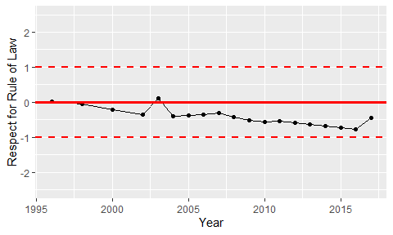

Trend of the Respect for the Rule of Law